I230549 COAL LAB 2

Q1) 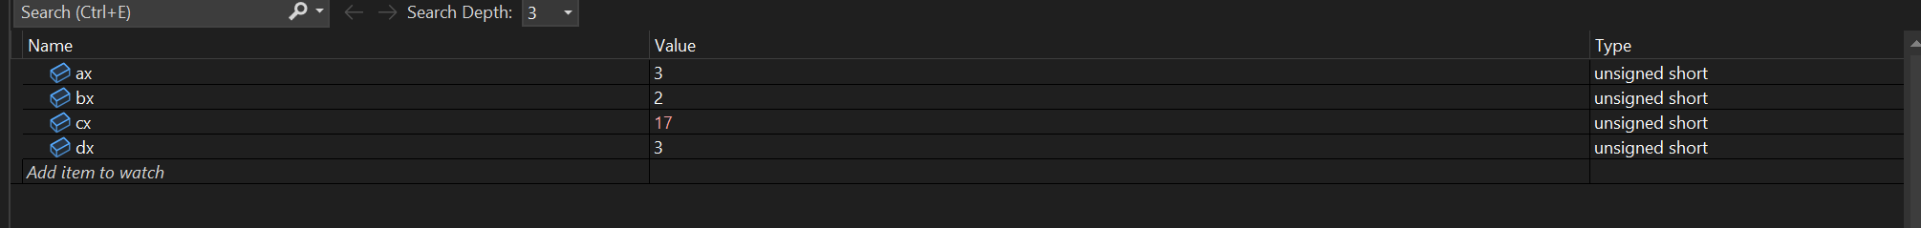

Q2) 

Q3) 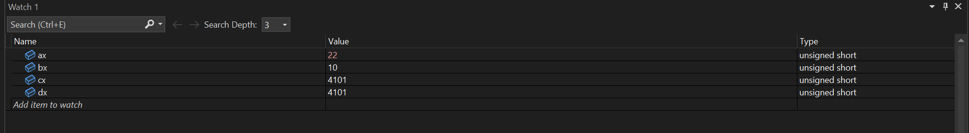

Q4) 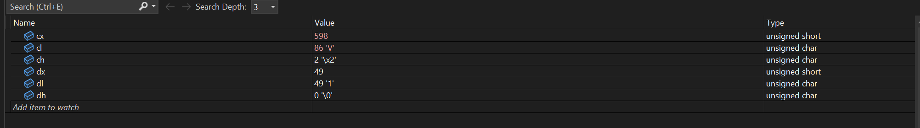

Q5) 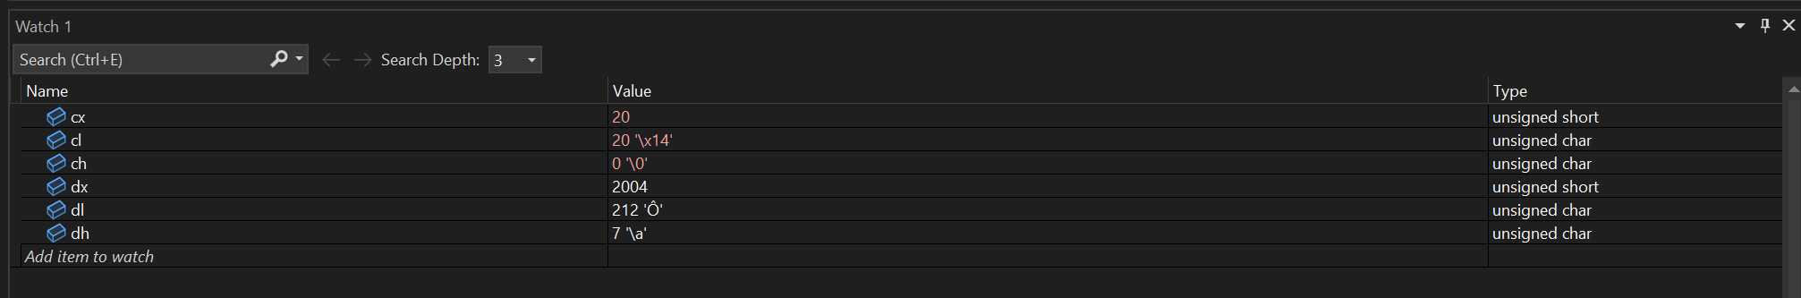

Q6) 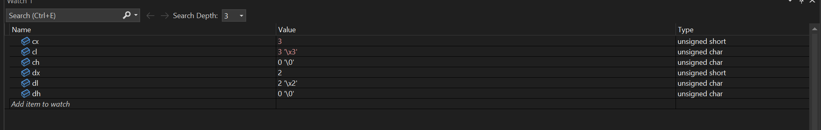

Q7) 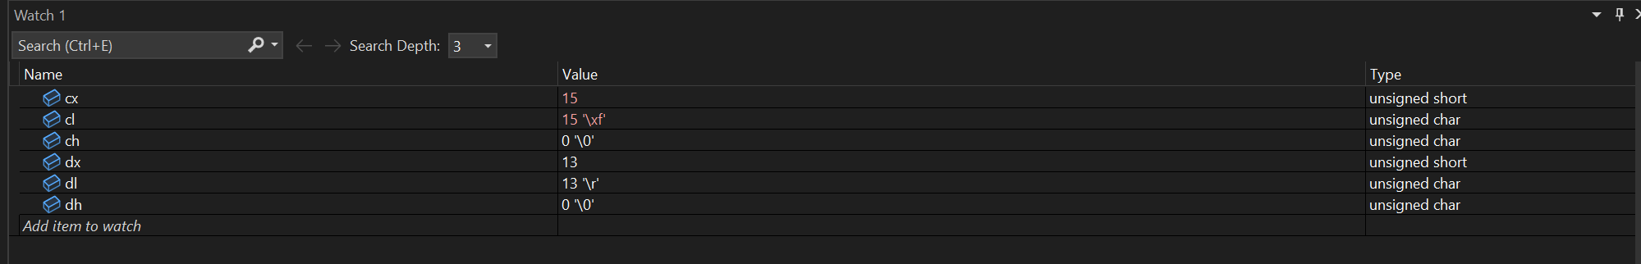

Q10) 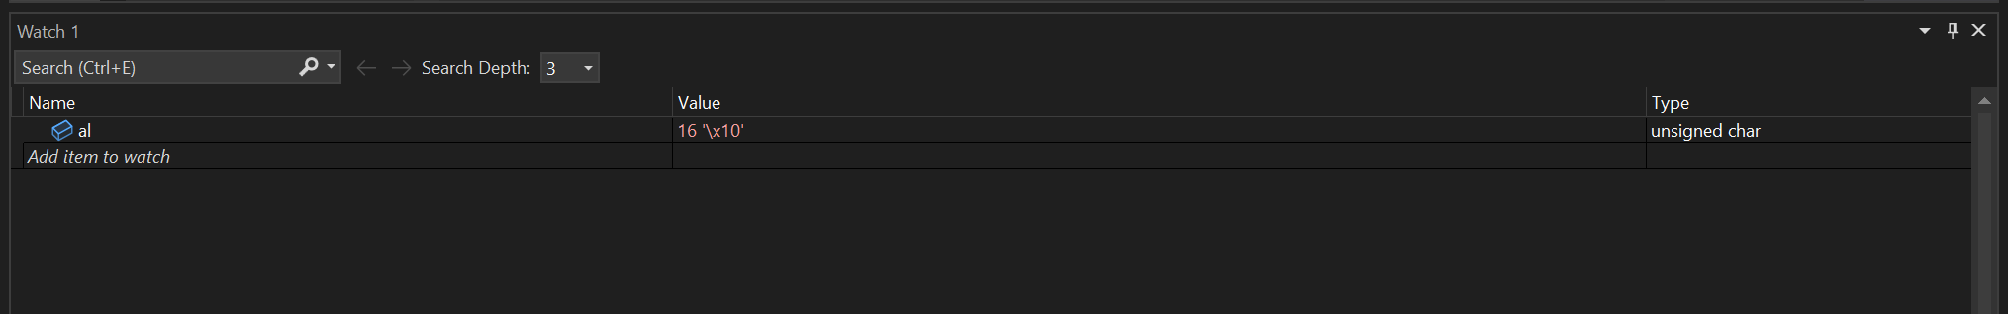

Q12) Memory was not showing on my computer

.386

.model flat, stdcall

.stack 4096

.data

var1 db 10

var2 db 6

n BYTE "Mustafa",0

s db 7

.code

main PROC

; Q1

comment @

mov ax, 1

mov bx, 2

add ax, bx

mov cx, 20

mov dx, 3

sub cx, dx

mov al, 2

mov ah, 4

add al, ah

mov bl, 5

mov bh, 6

add bl, bh

mov cl, 6

mov ch, 2

sub cl, ch

mov dl, 1

mov dh, 5

sub dl, dh

; Q2

mov ax, 2

mov cx, 5

mov bx, 10

mov dx, 5

add ax, cx

sub bx, dx

mov al, 1

mov ah, 5

mov bl, 2

mov bh, 5

mov cl, 3

mov ch, 5

mov dl, 4

mov dh, 5

add al, ah

add bl, bh

sub cl, ch

sub dl, dh

; Q3

mov ax, 12 ; ax = 12, al = 12, ah = 0

mov bx, 10 ; bx = 10, bl = 10, bh = 0

add ax, bx ; ax = 22, al = 22, ah = 0

; Q4

mov cx, 0549

mov dx, 0049

add cx, dx ; 0549 + 0049 = 0598

; Q5

mov cx, 2024

mov dx, 2004

sub cx, dx ; 2024 - 2004 = 20

; Q6

mov cx, 001b

mov dx, 010b

add cx, dx ; 1 + 2 = 3

; Q7

mov cx, 010b

mov dx, 0Dh

add cx, dx ; 2 + 13 = 15

; Q8

mov cx, 010b

mov dx, 05o

add cx, dx ; 2 + 5 = 7

; Q9

mov cx, 0Dh

mov dx, 05o

add cx, dx ; 13 + 5 = 18

; Q10

mov al, var1 ; var 1 = 6, var 2 = 10

add al, var2 ; 6 + 10 = 16

; Q11

mov al, var1 ; var 1 = 6, var 2 = 10

sub al, var2 ; 10 - 6 = 4

@

; Q 12

main ENDP

END main